prof. Tadeusz Górecki
Waterloo University, Waterloo ON, Canada
10.06.2017-09.07.2017
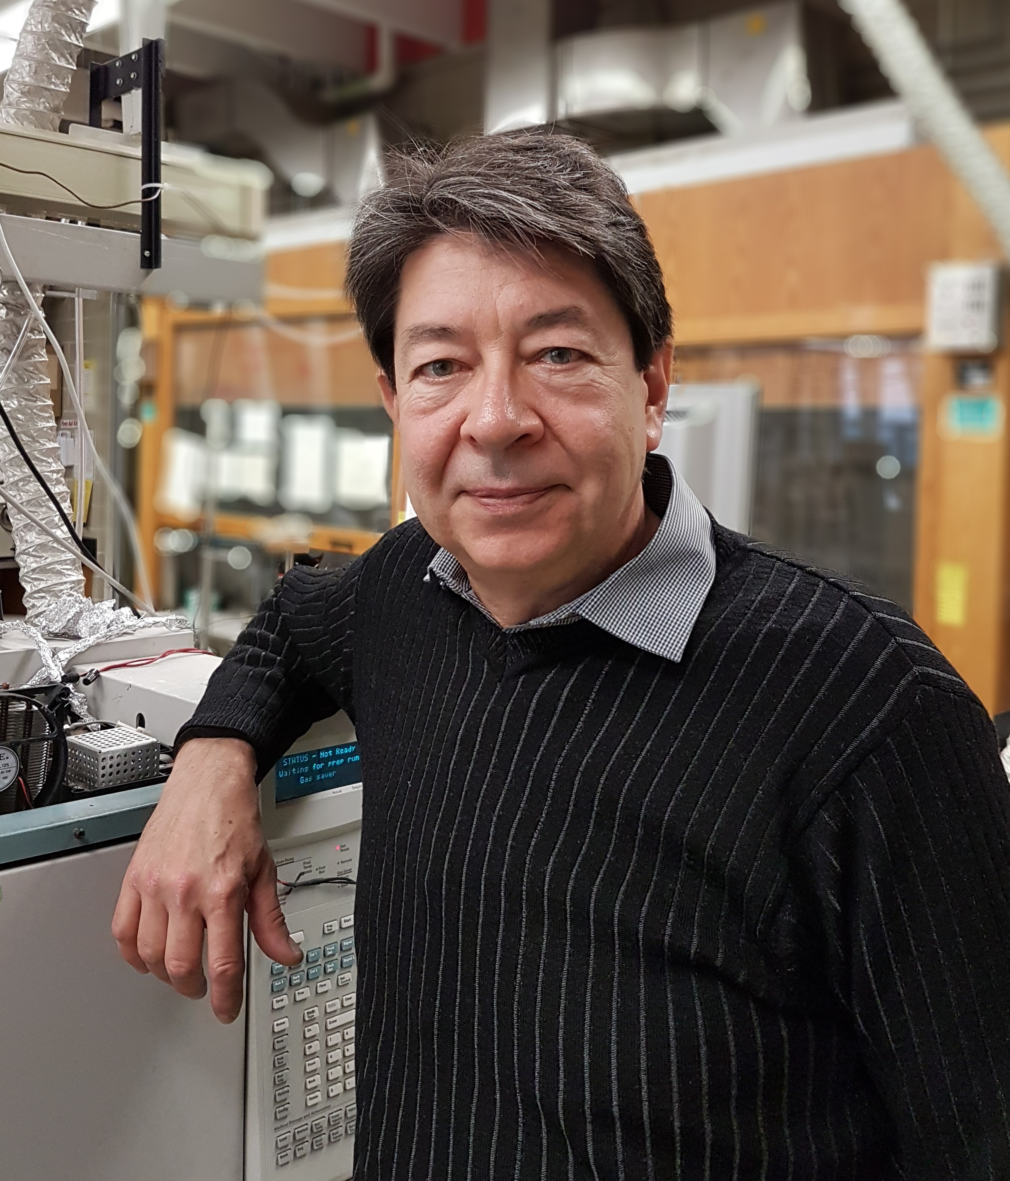
Curriculum Vitae (CV)
Tadeusz Górecki, a Canadian citizen, is a professor at the Department of Chemistry, University of Waterloo, (Waterloo, Ontario, Canada). He obtained his M.Sc. Eng. (2001) and Ph.D. (2006) degrees from the Gdańsk University of Technology (Poland). He arrived in Waterloo in 1993, first as a post-doctoral fellow, then a research associate. He has been holding a Faculty position at the University of Waterloo since 1998, and became a full professor in 2007. In 2009, he was granted the degree of Professor of Chemical Sciences by the President of the Republic of Poland. He is an author/co-author of 24 books/book chapters, 160 peer reviewed papers, 288 conference presentations (including 66 invited lectures) and 7 patents/patent applications. His papers have been cited numerous times (Google Scholar: 5,534 as of May 12, 2007; ISI Web of Knowledge: 3729/3433 without self citations). His h-index is 42/34 (Google Scholar/ISI), and the i-10 index is 100 (Google Scholar, May 2017). He serves as a regional editor for Current Chromatography (Bentham Science). He reviews numerous manuscripts for the most prestigious analytical journals. In 2016 Prof. Górecki was awarded the Waksmundzki Medal by the Committee on Analytical Chemistry of the Polish Academy of Sciences for his contributions to separation science. He is also the recipient of the 2017 GCxGC Lifetime Achievement Award, awarded at the 41st International Symposium on Capillary Chromatography & the 14th GCxGC Symposium (Fort Worth, TX).
Prof. Górecki’s research focuses on separation science. He is recognized internationally as one of the pioneers in the field of comprehensive two-dimensional gas chromatography (GC×GC). His contributions include the development of novel GC×GC modulators, method optimization, introduction of temperature programming in the 2nd dimension, and invention of stop-flow GC×GC. The basic tenet of the latter approach, stopping the flow of the carrier gas momentarily in the first dimension column, now forms the foundation of flow modulation, which is quickly gaining popularity around the world.
In the area of liquid phase separations, Prof. Górecki addressed the issue of “greening” liquid phase separations by using HPLC columns packed with highly efficient, fully- or superficially porous small packing particles at elevated temperatures. He also developed the so-called mobile-phase compensation method which allows obtaining uniform responses during gradient elution from evaporative detectors including charged aerosol detector (CAD) and evaporative light-scattering detector (ELSD) in combination with both HPLC and supercritical fluid chromatography (SFC). The approach is offered commercially by Thermo Scientific with their CAD detectors. Recently, Prof. Górecki proposed a new approach to comprehensive two-dimensional liquid chromatography (LCxLC) based on parallel gradients and similar separation mechanisms in both dimensions, mirroring the approach used in GCxGC. The new approach vastly simplifies LCxLC, potentially bringing it closer to widespread adoption.
In the area of environmental analysis, Prof. Górecki developed a number of enhanced extraction methods for volatile organic compounds (VOCs) in low permeability media based on ultrasonic and microwave-assisted extraction. The latter has been used successfully for many years now by his collaborators at the University of Guelph. He also developed a unique permeation passive sampler for VOCs in gas phase, which is available commercially from SiREM (Guelph, ON) under the name Waterloo Membrane Sampler (WMS). WMS is the only passive sampler that can provide quantitative information on analyte concentrations in soil gas rather than just the amounts of analytes sorbed. It has been used for field investigations throughout the United States, Canada, Mexico, Australia, United Kingdom and several countries in Asia. It was approved by the New Jersey Department of Environmental Protection for site-specific uses in 2009, and by the Ministry of Environmental Protection in Israel for the purpose of collecting soil gas samples in 2015.
Prof. Górecki is also a co-inventor of the non-discriminating pyrolysis method, which provides information on higher molecular weight pyrolysis products compared to standard pyrolysis approaches. These fragments often carry the most significant structural information about the sample, yet they suffer from discrimination on transfer from standard pyrolysis devices to the gas chromatographic systems.
Prof. Górecki has numerous collaborations around the world, including scientists from the Gdańsk University of Technology (Poland), Center for Environmental Research in Leipzig (Germany), University of Tasmania (Australia), Stellenbosch University (South Africa), Penn State University (USA), Ghent University (Belgium), UC Berkeley (USA), etc.
Joint publication list
- J. Płotka, M. Tobiszewski, A.M. Sulej, M. Kupska, T. Górecki, J. Namieśnik, “Green Chromatography”, Journal of Chromatography A, 1307 (2013), 1-20.
- T. Dymerski, T. Chmiel, A. Mostafa, M. Śliwińska, P. Wiśniewska, W. Wardencki, J. Namieśnik, T Górecki, “Botanical and Geographical Origin Characterization of Polish Honeys by Headspace SPME-GC×GC-TOFMS”, Current Organic Chemistry, 17(8) (2013), 853-870.
- M. Bielski, T. Górecki, J. Namieśnik, “Kompletna dwuwymiarowa chromatografia gazowa - nowoczesne narzędzie analityczne. Cz. II: Aparatura” (“Comprehensive two-dimensional gas chromatography – a modern analytical tool. Part II: Instrumentation”), Analityka (Poland), 4 (2011), 4-9.
- M. Bielski, T. Górecki, J. Namieśnik, “Kompletna dwuwymiarowa chromatografia gazowa - nowoczesne narzędzie analityczne. Cz. I: Podstawy techniki” (“Comprehensive two-dimensional gas chromatography – a modern analytical tool. Part I: Fundamentals”), Analityka (Poland), 3 (2011), 18-22.
- Ż. Polkowska, T. Górecki, J. Namieśnik, “Determination of atmospheric pollutants in wet deposition”, Environmental Reviews 19 (2011) 185-213.
- K. Kozlowska-Tylingo, J. Namieśnik, T. Górecki, “Determination of estrogenic endocrine disruptors in environmental samples – a review of chromatographic methods”, Critical Reviews in Analytical Chemistry, 40(3) (2010), 194-201.
- K. Klimaszewska, P. Konieczka, Z. Polkowska, T. Górecki, J. Namieśnik, “Comparison of Ion Chromatography and Isotachophoresis for the Determination of Selected Anions in Atmospheric Wet Deposition Samples”, Polish Journal of Environmental Studies 19(1) (2010), 93-99.
- M. Urbanowicz, B. Zabiegała, J. Namieśnik, T. Górecki, "Spatial and seasonal patterns of BTEX in the Tricity (Poland) determined using Radiello passive samplers", Journal of Environmental Quality, 39 (2010), 896–906.
- Ż. Polkowska, M. Tobiszewski, T. Górecki and J. Namieśnik, “Pesticides in rain and roof runoff waters from an urban region”, Urban Water Journal, 6 (2009), 441 – 448.
- Ż. Polkowska, K. Skarżyńska, T. Górecki, J. Namieśnik, “Formaldehyde in various forms of atmospheric precipitation and deposition from highly urbanized regions”, Journal of Atmospheric Chemistry, 53 (2006) 211-236.
- B. Zabiegała, M. Partyka, T. Górecki, J. Namieśnik, “Application of the GC retention index system for the determination of the calibration constants of permeation passive samplers with PDMS membranes”, Journal of Chromatography A, 1117 (2006) 19-30.
- L. Wolska, M. Rawa-Adkonis, T. Górecki, B. Zygmunt, J. Namieśnik, “Determination of Polycyclic Aromatic Hydrocarbons and Polychlorinated Biphenyls in Natural Waters: Problems and Challenges”. Chemia Analityczna (Poland), 51, (2006), 35-49.
- Z. Polkowska, K. Kozłowska, P. Konieczka, N. Jakubowska, T. Górecki, J. Namieśnik, “Thin Layer Head Space gas chromatography for biological monitoring of persons exposed to volatile organohalogen compounds from water”, Chemia Analityczna (Poland), 51 (2006), 109-122.
- Ż. Polkowska, K. Kozłowska, Z. Mazerska, T. Górecki, J. Namieśnik, “Volatile organohalogen compounds in human urine: The effect of environmental exposure”, Chemosphere, 62 (4), (2006), 626-640.
- Ż. Polkowska, B. Zabiegała, T. Górecki, J. Namieśnik, “Effect of highway pollutants in urban runoff”, Polish Journal of Environmental Studies, 14(6) (2005), 799-807.
- Ż. Polkowska, A. Astel, B. Walna, S. Małek, T. Górecki, J. Siepak, J. Namieśnik, “Chemometric analysis of rainwater and throughfall at several sites in Poland”, Atmospheric Environment, 39 (2005) 837–855.
- Ż. Polkowska, K. Kozłowska, T. Górecki, J. Namieśnik, “The Effect of Chlorinated Drinking Water Consumption on Levels of Volatile Organohalogen Compounds in Urine”, American Laboratory News, June 2004, 29-32.
- Ż. Polkowska, K. Kozłowska, Z. Mazerska, T. Górecki, J. Namieśnik, “Relationship between Volatile Organohalogen Compounds in Drinking Water and Human Urine in Poland”, Chemosphere, 53 (2003), 899-909.
- M. Grynkiewicz, Ż. Polkowska, T. Górecki, J. Namieśnik, “Pesticides in precipitation from an urban region in Poland (Gdansk-Sopot-Gdynia Tricity) between 1998 and 2000”, Water, Air and Soil Pollution, 149 (2003), 3-16.
- B. Zabiegała, T. Górecki, J. Namieśnik, “Calibration of permeation passive samplers with silicone membranes based on physico-chemical properties of the analytes”, Analytical Chemistry, 75 (2003), 3182-3192.
- Ż. Polkowska, T. Górecki, J. Namieśnik, "Quality of roof runoff waters from an urban region (Gdańsk, Poland)", Chemosphere, 49 (2002), 1275-1283.
- B. Zabiegała, T. Górecki, E. Przyk, J. Namieśnik, “Permeation passive sampling as a tool for the evaluation of indoor air quality”, Atmospheric Environment, 36 (2002), 2907-2916.
- T. Górecki, J. Namieśnik, “Passive Sampling”, TrAC 21(4) (2002), 276-291.
- J. Namieśnik, T. Górecki, “Application of Total Parameters in Environmental Analytics”, Am. Environ. Lab., 34(4) (2002) 18-21.
- Ż. Polkowska, A. Astel, M. Grynkiewicz, T. Górecki, J. Namieśnik, “Studies on Intercorrelation between Ions Co-occurring in Precipitation in the Gdańsk-Sopot-Gdynia Tricity (Poland)”, J. Atmos. Chem., 41(3) (2002), 239-264.
- Ż. Polkowska, T. Górecki, J. Namieśnik, “Determination of Non-Metabolized Organohalogen Solvents in Human Urine by Thin-Layer Headspace Analysis”, Am. Clinical Lab., September 2001, 38-43.
- J. Namieśnik, T. Górecki, “Preparation of Environmental Samples for the Determination of Trace Constituents”, Polish Journal of Environmental Studies, 10(2), 77-84 (2001).
- J. Namieśnik, T. Górecki, “Quality of Analytical Results”, Revue Roumaine de Chimie, 46(9), 953-962 (2001).
- M. Grynkiewicz, Ż. Polkowska, T. Górecki, J. Namieśnik, “Pesticides in Precipitation in the Gdańsk Region (Poland)”, Chemosphere, 43, 303-312 (2001).
- M. Grynkiewicz, Ż. Polkowska, T. Górecki, J. Namieśnik, “Volatile Organohalogen Compounds and Pesticides in Precipitation from an Urban Region (Gdańsk, Poland)”, Analytical Letters, 34(9), 1503 - 1515 (2001).
- Ż. Polkowska, M. Grynkiewicz, T. Górecki, J. Namieśnik, “Concentration Levels of Lead in Precipitation from Large Urban Agglomerations (Gdańsk, Gdynia) in Poland”, Journal of Environmental Monitoring, 3 (2001), 146-149.
- J. Namieśnik, T. Górecki, “Sample Preparation for Chromatographic Analysis of Plant Material”, Journal of Planar Chromatography, 13, 404-413 (2000).
- J. Namieśnik, T. Górecki, “Passive Sampling in Environmental Analysis”, LC-GC Europe, 13(9), 678-683, (2000).
- E. Przyk, B. Zabiegała, T. Górecki, J. Namieśnik, “Methods for the Control of Indoor Air Quality”, Chemia Analityczna (Warsaw, Poland), 45, 631 (2000).
- L. Wolska, K. Galer, T. Górecki, J. Namieśnik, “Surface Water Preparation Procedure for Chromatographic Determination of Polycyclic Aromatic Hydrocarbons and Polychlorinated Biphenyls”, Talanta, 50(5), 985-991 (1999).
- L. Wolska, M. Wiergowski, K. Galer, T. Górecki, J. Namieśnik, “Sample Preparation for GC Analysis of Selected Pesticides in Surface Water”, Chemosphere, 39(9), 1477-1486 (1999).
- Ż. Polkowska, T. Górecki, J. Namieśnik, “Determination of Volatile Organohalogen Compounds in Human Urine”, Applied Occupational and Environmental Hygiene, 14, 240-245 (1999).
- Ż. Polkowska, E. Kozłowski, T. Górecki, J. Namieśnik, “Theoretical Principles of Thin Layer Headspace Analysis”, Toxicological and Environmental Chemistry, 68, 1-42 (1999).
- Ż. Polkowska, M. Turska, T. Górecki, J. Namieśnik, “Comparison of the New Version of Thin Layer Headspace Analysis with Autogenous Generation of the Liquid Sorbent (TLHS-DAI-GC-ECD) with Classical Liquid-Liquid Extraction (LLE-GC-ECD) for the Determination of Volatile Organohalogen Compounds in Liquid Samples”, Process Control and Quality, 11(1), 1-8 (1998).
- J. Czerwiński, J. Namieśnik, T. Górecki, “Application of Flow-Injection Analysis Methods for the Determination of Organic Compounds in Liquid Samples”, Polish Journal of Environmental Studies 3; 5 - 14 (1994).

Lectures
Selected Topics in Experimental Design and Chemometrics

Experimentation is one of the foundational pillars of science. Any theoretical hypothesis that is
formulated must ultimately be proved or disproved by experiments. While the scientific method is generally intuitively understood by researchers, not all of them fully realize how various controllable and uncontrollable factors might affect their results. Also, the approach to
experimentation is often far from optimal. The course will try to fill these voids by exploring the
areas mentioned above. It will begin by introducing the tools needed to evaluate the sources of variation in data through the analysis of variance (ANOVA). This will be followed by a discussion of calibration approaches, method ruggedness and sensitivity. Once these issues are understood, the focus will shift towards experimental designs that allow gaining a multitude of insights in a minimum number of experiments. Approaches discussed will include block designs with all their variants (randomized block designs, Latin square designs, Graeco-Latin squares, etc.), factorial and fractional factorial designs, composite designs, mixture designs and Plackett-Burman designs. In the last part of the course issues related to experimental optimization will be discussed. Approaches ranging from sequential “one-factor-at-a-time” through evolutionary operation to response surface methods will be covered. Finally, purely experimental simplex optimization will be introduced.

References:
G.E.P. Box, J.S. Hunter, W.G. Hunter, “Statistics for Experimenters”, 2nd Ed., Wiley Interscience, 2005
D.L. Massart, B.G.M. Vandeginste, S.M. Deming, Y. Michotte, L. Kaufman, “Chemometrics: a
textbook”, Elsevier, 2003
R.G. Brereton, “Applied Chemometrics for Scientists”. J. Wiley & Sons, 2007

Proposed seminar topics
- Introduction to multidimensional separations
- Comprehensive two-dimensional gas chromatography (GCxGC)
- GCxGC instrumentation
- GCxGC optimization
- GCxGC applications
- Introduction to LCxLC
- Green aspects of chromatography
- Passive sampling
- Modelling of the permeation passive sampling process
- Introduction to experimental design and optimization

Proposed research area:
- Application of multidimensional techniques in environmental analysis

